Module 5
1. Revenue Strategy
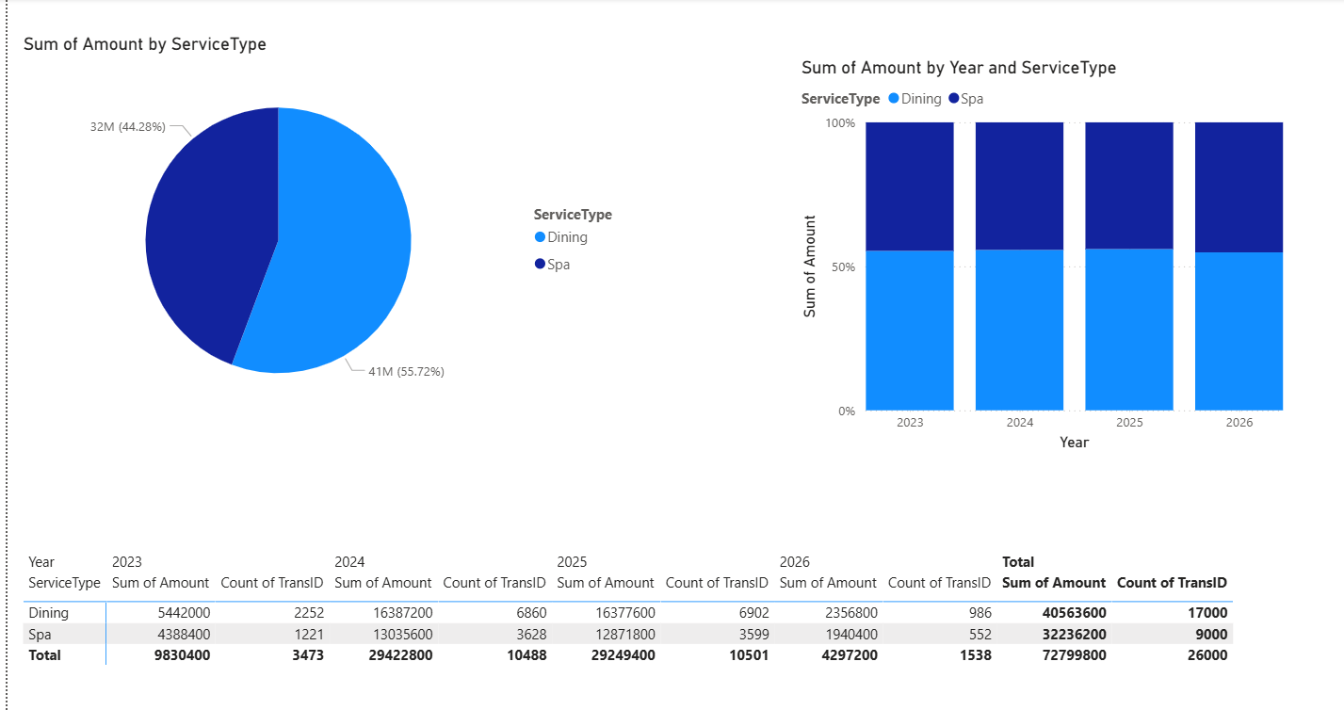

2. Recommend pricing tiers
